**1)** **Write a query to fetch all customer names and sort them alphabetically. (Topic Soring)**

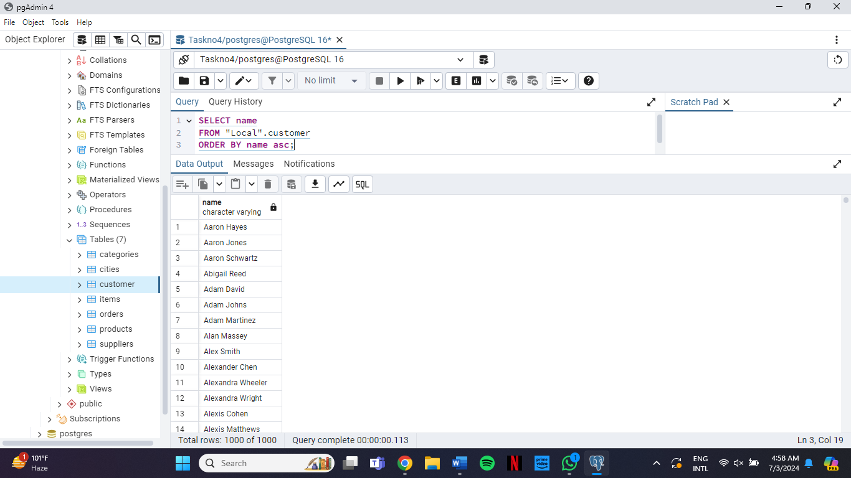

**2)**  **Write a query to fetch all product names and their prices, sorted by price from low to high. (Topic Sorting)**

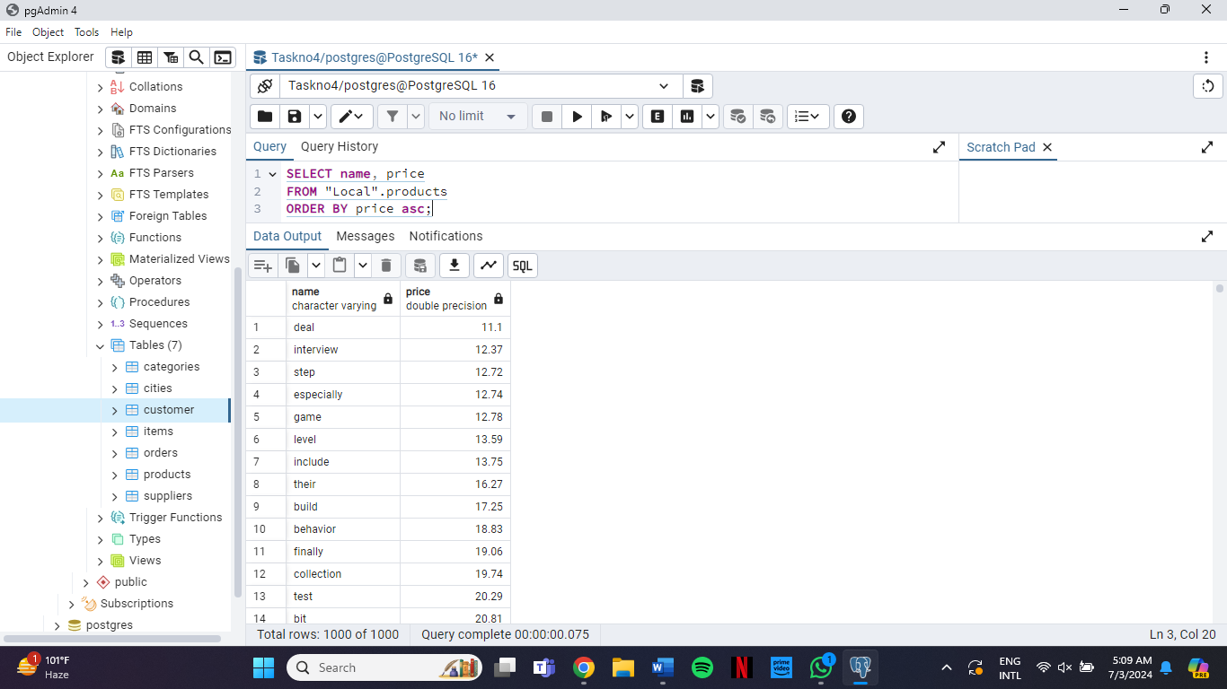

**3)** **Write a query to fetch supplier names that start with the letter 'A' and sort them by their names. (Topic Sorting with Operators and Wildcards)**

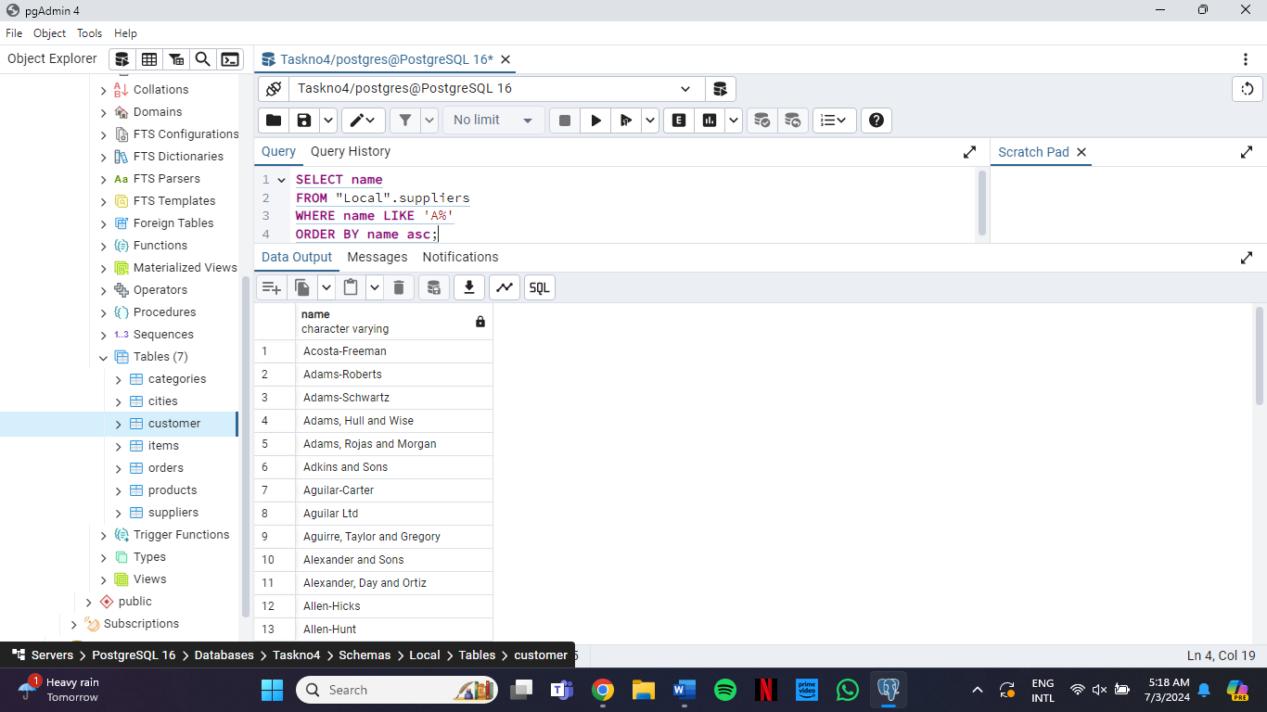

**4) Write a query to fetch all items and sort them by their status, placing NULL values first.**

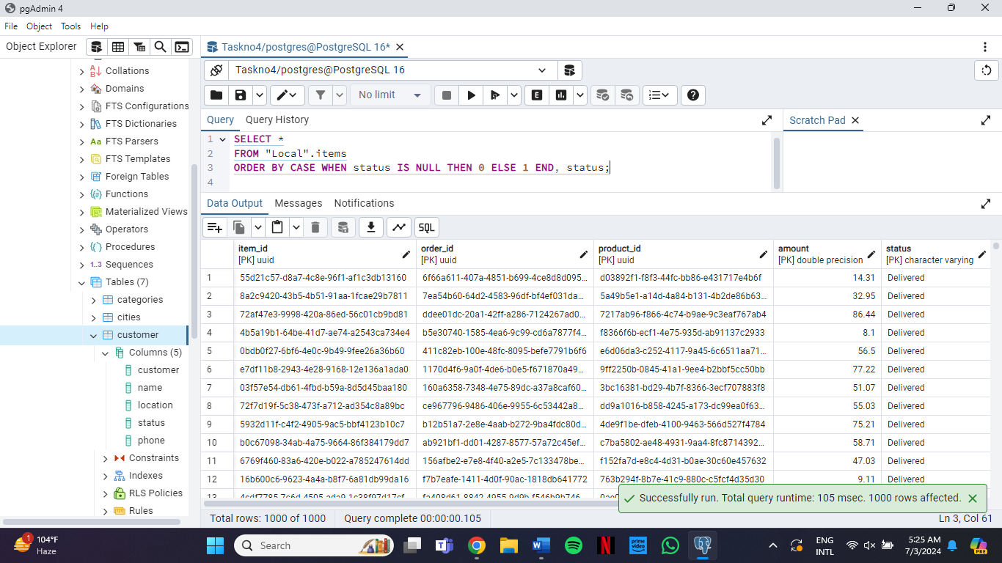

**5) Write a query to fetch all products, sort them first by category and then by price in descending order.**

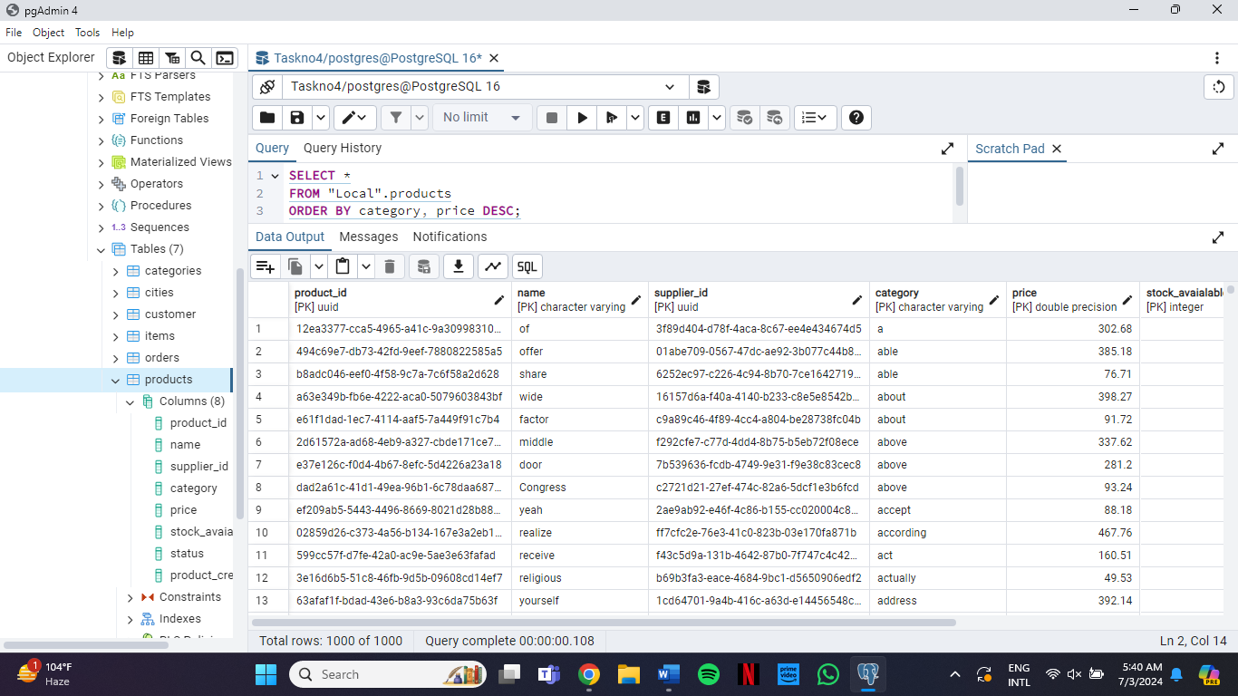

**6) Write a query to fetch all customer names and phone numbers, but sort them by the last four digits of their phone numbers in ascending order. (Hint use sorting with substings)**

